МИНИСТЕРСТВО ТРАНСПОРТА РОССИЙСКОЙ ФЕДЕРАЦИИ
ФЕДЕРАЛЬНОЕ АГЕНТСТВО ЖЕЛЕЗНОДОРОЖНОГО ТРАНСПОРТА
Государственное бюджетное образовательное учреждение
высшего образования
«ПЕТЕРБУРГСКИЙ ГОСУДАРСТВЕННЫЙ УНИВЕРСИТЕТ
ПУТЕЙ СООБЩЕНИЯ ИМПЕРАТОРА АЛЕКСАНДРА I»

Кафедра «ИНФОРМАЦИОННЫЕ И ВЫЧИСЛИТЕЛЬНЫЕ СИСТЕМЫ»

Дисциплина: «Программирование(C)»

ОТЧЕТ
по лабораторной работе № 6

Вариант 19

Выполнил студент Шефнер А.
Факультета АИТ
Группы ИВБ-211

Санкт-Петербург
2023

Постановка задачи
1) Создать односвязный список. Данными списка должны быть структуры из задания № 4 соответствующего варианта. Создать функции для записи списка в файл и чтения списка из файла.

2) Реализовать минимум все функции, приведённые в лекции, предложить предложить свои варианты функций работы со списком.

3) Создать меню для управления работы со списком.

Пояснения
Мой список является отдельной структурой list, в которой находится количество элементов, ссылка на голову и ссылка на хвост листа. Данные хранятся в узлаъ node в виде указателей на void. Это позволяет Вам использовать данный список не только со структурой book, но и вообще с любыми другими структурами, если Вы работаете с ними через указатели. Для очистки списка сначала примените процедуру free для каждого элемента (это может сделать моя функция list_apply), а зачем вызовате list_delete.

Код программы

c_lab_6.c (точка входа программы и меню взаимодействия со списком)
#define _CRT_SECURE_NO_WARNINGS

#include <stdio.h>
#include <stdlib.h>

#include "book.h"
#include "list.h"
#include "booksfile.h"

#define ACTION_COUNT 14

list* book_list;

void(*actions[ACTION_COUNT])(void);

char* action_names[ACTION_COUNT];

void action_get_head(void);
void action_list_get_tail(void);
void action_list_get(void);
void action_get_from_end(void);
void action_show_list(void);
void action_push_back(void);
void action_push_front(void);
void action_insert(void);
void action_pop_back(void);
void action_pop_front(void);
void action_remove_at(void);
void action_remove_from_end(void);
void action_load_from_file(void);
void action_write_to_file(void);

// void** list_to_array(const list* list);

void init_actions(void);
void print_actions(void);

int main(int argc, char* argv[])
{
system("cls");
init_actions();
book_list = list_create();

printf("Welcome to the book management tool!\n");

while (1)
{
system("pause");
system("cls");

print_actions();

int action_num;
printf("Enter action number: ");
scanf("%d", &action_num);
if(action_num == 0) break;
if(action_num < 1 || action_num > ACTION_COUNT)
{
printf("Invalid action number.\n");
continue;
}
system("cls");
fseek(stdin,0,SEEK_END);
actions[action_num - 1]();
}

list_apply(book_list, free);
list_delete(book_list);

system("pause");

return 0;
}

void action_get_head(void)
{
printf("Head of the list:\n\n");
book_print(list_get_head(book_list));
}

void action_list_get_tail(void)
{
printf("Tail of the list:\n\n");
book_print(list_get_tail(book_list));
}

void action_list_get(void)
{
size_t index;
printf("Enter desired index: ");
scanf("%lld", &index);

book* book = list_get(book_list, index);

if(book == NULL)
{
printf("Invalid index.\n");
return;
}

printf("Book at index %lld in the list:\n\n", index);
book_print(book);
}

void action_get_from_end(void)
{
size_t index;
printf("Enter desired index: ");
scanf("%lld", &index);

book* book = list_get_from_end(book_list, index);

if(book == NULL)
{
printf("Invalid index.\n");
return;
}

printf("Book at index %lld in the list:\n\n", index);
book_print(book);
}

void action_show_list(void)
{
if(book_list->count == 0)
{
printf("The list is empty.\n");
return;
}
printf("List of the books:\n\n");
list_apply(book_list, book_print);
printf("\n\n");
}

void action_push_back(void)
{
printf(" Enter book:\n");
book* new_book = book_get_scanf();
list_push_back(book_list, new_book);
printf("\nBook added to list successfully.\n\n");
}

void action_push_front(void)
{
printf(" Enter book:\n");
book* new_book = book_get_scanf();
list_push_front(book_list, new_book);
printf("\nBook added to list successfully.\n\n");
}

void action_insert(void)
{
size_t index;
printf("Enter index (0 - %lld): ", book_list->count);
scanf("%lld", &index);
if(index < 0 || index >= book_list->count)
{
printf("Invalid index.\n");

}
printf(" Enter book:\n");
book* new_book = book_get_scanf();
list_insert(book_list, new_book, index);
printf("\nBook added to list successfully.\n\n");
}

void action_pop_back(void)
{
book* removed_book = list_pop_back(book_list);
if(removed_book == NULL)
{
printf("The list is empty.\n");
return;
}
printf("The book, popped out from back:\n\n");
book_print(removed_book);
free(removed_book);
}

void action_pop_front(void)
{
book* removed_book = list_pop_front(book_list);
if(removed_book == NULL)
{
printf("The list is empty.\n");
return;
}
printf("The book, popped out from front:\n\n");
book_print(removed_book);
free(removed_book);
}

void action_remove_at(void)
{
size_t index;
printf("Enter index (0 - %lld): ", book_list->count);
scanf("%lld", &index);
if(index < 0 || index >= book_list->count)
{
printf("Invalid index.\n");

}

book* removed_book = list_get(book_list, index);
list_remove_at(book_list, index);
printf("\nThe book, removed from the list:\n\n");
book_print(removed_book);
free(removed_book);
}

void action_remove_from_end(void)
{
size_t index;
printf("Enter index (0 - %lld): ", book_list->count);
scanf("%lld", &index);
if(index < 0 || index >= book_list->count)
{
printf("Invalid index.\n");

}

book* removed_book = list_get(book_list, index);
list_remove_at_from_end(book_list, index);
printf("\nThe book, removed from the list:\n\n");
book_print(removed_book);
free(removed_book);
}

void action_load_from_file(void)
{
char filename[100];
printf("Enter file name: ");
scanf("%s", filename);

list* tmp_list = get_book_list_from_file(filename);
if(tmp_list == NULL)
{
printf("Invalid file name.\n");
return;
}

list_apply(book_list, free);
free(book_list);
book_list = tmp_list;

printf("Books loaded successfully\n");
}

void action_write_to_file(void)
{
char filename[100];
printf("Enter file name: ");
scanf("%s", filename);

if(write_book_list_to_file(filename, book_list))
{
printf("Data successfully written to the file.\n");
}
else
{
printf("Error during writing the list to file.\n");
}
}

void init_actions(void)
{
actions[0] = action_get_head;
action_names[0] = "Get head of the list.";

actions[1] = action_list_get_tail;
action_names[1] = "Get tail of the list.";

actions[2] = action_list_get;
action_names[2] = "Get an element of the list at desired index.";

actions[3] = action_get_from_end;
action_names[3] = "Get an element of the list at desired index starting from the end.";

actions[4] = action_show_list;
action_names[4] = "Print all elements of the list.";

actions[5] = action_push_back;
action_names[5] = "Push back anew element to the list.";

actions[6] = action_push_front;
action_names[6] = "Push front anew element to the list.";

actions[7] = action_insert;
action_names[7] = "Insert a new elenebt in the list at the desired index.";

actions[8] = action_pop_back;
action_names[8] = "Pop back an element from the list and show it.";

actions[9] = action_pop_front;
action_names[9] = "Pop front an element from the list and show it.";

actions[10] = action_remove_at;
action_names[10] = "Remove an element from the list at the desired index.";

actions[11] = action_remove_from_end;
action_names[11] = "Remove an element from the list at the desired index starting from the end.";

actions[12] = action_load_from_file;
action_names[12] = "Load books from the file.";

actions[13] = action_write_to_file;
action_names[13] = "Write books to the file.";

}

void print_actions(void)
{
for(int i = 0; i < ACTION_COUNT; i++)
{
printf("%d - %s\n", i + 1, action_names[i]);
}
printf("\n%d - Exit.\n\n", 0);
}

book.h (струтура книги и основные функции)
#pragma once

#define SURNAME_CHAR_NUMBER 20
#define THEME_CHAR_NUMBER 50
#define FULL_CHAR_NUMBER 83

#define SURNAME_FORMAT "%20s"
#define THEME_FORMAT "%50s"
#define YEAR_FORMAT "%5hu"
#define PAGE_FORMAT "%5hu"

#define BOOK_FORMAT SURNAME_FORMAT" "THEME_FORMAT" "YEAR_FORMAT" "PAGE_FORMAT

typedef struct book
{
char surname[SURNAME_CHAR_NUMBER + 1];
char theme[THEME_CHAR_NUMBER + 1];
unsigned short year;
unsigned short page_count;
} book;

void book_print(book* book);

book* book_get_scanf(void);

book.с
#define _CRT_SECURE_NO_WARNINGS

#include "book.h"

#include <stdio.h>
#include <stdlib.h>
#include <string.h>

void write_str_without_trailing_spaces(char* str_ptr)
{
while (*str_ptr == ' ') str_ptr++;
while (*str_ptr != '\0')
{
char tmp = *str_ptr == '_' ? ' ' : (char)(*str_ptr);
putc(tmp, stdout);
str_ptr++;
}
}

void book_print(book* book)
{
write_str_without_trailing_spaces(book->surname);
printf(" - ");
write_str_without_trailing_spaces(book->theme);
printf("\nyear: %d. %d pages.\n\n", book->year, book->page_count);
}

book* book_get_scanf(void)
{
fseek(stdin,0,SEEK_END);

book* book = malloc(sizeof(struct book));

printf("\nEnter surname:\n");
fgets(book->surname, SURNAME_CHAR_NUMBER, stdin);
book->surname[strcspn(book->surname, "\r\n")] = '\0';

printf("Enter theme:\n");
fgets(book->theme, THEME_CHAR_NUMBER, stdin);
book->theme[strcspn(book->theme, "\r\n")] = '\0';

printf("Enter year: ");
scanf("%hd", &book->year);
printf("Enter page count: ");
scanf("%hd", &book->page_count);
return book;
}

list.h (связный список)
#pragma once

typedef unsigned long long size_t;

typedef struct node
{
void* data;
struct node* next;
} node;

typedef struct list
{
node* head;
node* tail;
size_t count;
} list;

// Creates a new list.
list* list_create(void);

// Returns a data of the lists head.
void* list_get_head(const list* list);

// Returns a data of the lists tail.
void* list_get_tail(const list* list);

// Returns a data from the list at index.
void* list_get(const list* list, size_t index);

// Returns a data from the list at index starting from end of list.
void* list_get_from_end(const list* list, size_t index);

// Converts a list to an array and returns a pointer to the array.
// Warning: a memory for an array is allocated with malloc.
// Don't forget to free the array after use.
void** list_to_array(const list* list);

// Adds a new element at the end of the list.
int list_push_back(list* list, void* data);

// Adds a new element at rhe start of the list
int list_push_front(list* list, void* data);

// Inserts a new element at a desired index.
int list_insert(list* list, void* data, size_t index);

// Removes an element from the end of the list and returns ins data
void* list_pop_back(list* list);

// Removes an element from the start of the list and returns ins data
void* list_pop_front(list* list);

// Removes an element from the list at index.
int list_remove_at(list* list, size_t index);

// Removes an element from the list at indext starting from the end.
int list_remove_at_from_end(list* list, size_t index);

// Applies a void function to every element of the list.
void list_apply(const list* list, void(*func)(void*));

// Applies a void function to every element of the list and
// saves the result to a new list.
// Warning: the new list will be allocated with malloc.
list* list_apply_and_save(const list* list, void*(*func)(void*));

// Deletes all the nodes of the list.
// Warning: data inside the nodes will not be deleted.
int list_delete(list* list);

list.с
#include "list.h"

#include <stdlib.h>

list* list_create(void)
{
list* list = malloc(sizeof(struct list));
list->count = 0;
list->head = NULL;
list->tail = NULL;
return list;
}

void* list_get_head(const list* list)
{
return list->head == NULL ? NULL : list->head->data;
}

void* list_get_tail(const list* list)
{
return list->tail == NULL ? NULL : list->tail->data;
}

void* list_get(const list* list, const size_t index)
{
if(index >= list->count || index < 0) return NULL;

const node* tmp = list->head;
for(size_t i = 0; i < index; i++)
{
tmp = tmp->next;
if(tmp == NULL) return NULL;
}

return tmp->data;
}

void* list_get_from_end(const list* list, const size_t index)
{
return list_get(list, list->count - index);
}

void** list_to_array(const list* list)
{
if(list->count == 0) return NULL;
void** array = malloc(sizeof(void*) * list->count);

const node* tmp = list->head;
for(size_t i = 0; i < list->count; i++)
{
array[i] = tmp->data;
tmp = tmp->next;
}

return array;
}

int list_push_back(list* list, void* data)
{
node* node_ptr = malloc(sizeof(node));

node_ptr->data = data;
if(list->count == 0)
list->head = node_ptr;
else
list->tail->next = node_ptr;
list->tail = node_ptr;

list->count++;

return 1;
}

int list_push_front(list* list, void* data)
{
if(list->count == 0)
{
return list_push_back(list, data);
}
node* new_node = malloc(sizeof(node));
new_node->data = data;
new_node->next = list->head;
list->head = new_node;
if(list->count == 1)
{
list->tail = list->head->next;
}
list->count++;
return 1;
}

int list_insert(list* list, void* data, const size_t index)
{
if(index > list->count || index < 0) return 0;
if(index == list->count) return list_push_back(list, data);
if(index == 0) return list_push_front(list, data);

node* tmp = list->head;
node* new_node = malloc(sizeof(node));
new_node->data = data;

for(size_t i = 0; i < index - 1; i++)
{
tmp = tmp->next;
}

new_node->next = tmp->next;
tmp->next = new_node;
list->count++;

return 1;
}

void* list_pop_back(list* list)
{
if(list->count == 0) return NULL;

void* return_data = list->tail->data;

if(list->count == 1)
{
free(list->tail);
list->tail = NULL;
list->head = NULL;
list->count--;
return return_data;
}

node* tmp = list->head;
for(size_t i = 0; i < list->count - 2; i++)
{
tmp = tmp->next;
}

free(list->tail);
list->tail = tmp;
list->count--;

return return_data;
}

void* list_pop_front(list* list)
{
if(list->count == 0) return NULL;
if(list->count == 1) return list_pop_back(list);

void* data = list->head->data;
node* tmp = list->head;
list->head = list->head->next;
free(tmp);
list->count--;
return data;
}

int list_remove_at(list* list, const size_t index)
{
if(list->count == 0 || index < 0) return 0;
if(index == 0)
{
list_pop_front(list);
return 1;
}
if(index == list->count - 1)
{
list_pop_back(list);
return 1;
}

if(list->count == 1)
{
free(list->head);
list->head = NULL;
list->tail = NULL;
return 1;
}

node* tmp = list->head;
for(size_t i = 0; i < index - 1; i++)
{
tmp = tmp->next;
}

node* removed = tmp->next;
tmp->next = removed->next;
free(removed);
list->count--;

return 1;
}

int list_remove_at_from_end(list* list, size_t index)
{
return list_remove_at(list, list->count - index);
}

void list_apply(const list* list, void(* func)(void*))
{
const node* tmp = list->head;
for(size_t i = 0; i < list->count; i++)
{
func(tmp->data);
tmp = tmp->next;
}
}

list* list_apply_and_save(const list* list, void*(* func)(void*))
{
struct list* new_list = list_create();

if(list->count == 0) return new_list;

const node* tmp = list->head;
node* tmp_new = malloc(sizeof(node));

new_list->head = tmp_new;
new_list->head->data = func(list->head->data);

for(size_t i = 0; i < list->count - 1; i++)
{
tmp_new->next = malloc(sizeof(node));
tmp_new = tmp_new->next;
tmp = tmp->next;
tmp_new->data = func(tmp->data);
}

new_list->tail = tmp_new;

new_list->count = list->count;

return new_list;
}

int list_delete(list* list)
{
if(list->count == 0)
{
free(list);
return 1;
}
if(list->count == 1)
{
free(list->head);
free(list);
return 1;
}

node* tmp = list->head;
for(size_t i = 0; i < list->count; i++)
{
node* tmp_next = tmp->next;
free(tmp);
tmp = tmp_next;
}
free(list);
return 1;
}

booksfile.h (функции для чтения из файла и запись в файл книг)
#pragma once

#include "list.h"

list* get_book_list_from_file(const char* path);

int write_book_list_to_file(char* path, list* list);

booksfile.с
#define _CRT_SECURE_NO_WARNINGS

#include "booksfile.h"

#include <stdio.h>
#include <stdlib.h>

#include "book.h"

list* get_book_list_from_file(const char* path)
{
FILE* file = fopen(path, "r");
if(!file) return NULL;

list* book_list = list_create();
char buf[300];

while(fgets(buf, 300, file))
{
book* new_book = malloc(sizeof(book));
int idx = 0;
for(int i = 0; i < SURNAME_CHAR_NUMBER; i++, idx++)
{
new_book->surname[i] = buf[idx];
}
new_book->surname[SURNAME_CHAR_NUMBER] = '\0';
idx++;

for(int i = 0; i < THEME_CHAR_NUMBER; i++, idx++)
{
new_book->theme[i] = buf[idx];
}
new_book->theme[THEME_CHAR_NUMBER] = '\0';
idx++;

char num_str[5];

for(int i = 0; i < 5; i++, idx++)
{
num_str[i] = buf[idx];
}
idx++;
new_book->year = atoi(num_str);

for(int i = 0; i < 5; i++, idx++)
{
num_str[i] = buf[idx];
}
new_book->page_count = atoi(num_str);

list_push_back(book_list, new_book);
}

fclose(file);

return book_list;
}

int write_book_list_to_file(char* path, list* list)
{
FILE* file = fopen(path, "w");
if(!file) return 0;

book** book_arr = list_to_array(list);
for(int i = 0; i < list->count; i++)
{
fprintf(file, BOOK_FORMAT"\n",
book_arr[i]->surname,
book_arr[i]->theme,
book_arr[i]->year,
book_arr[i]->page_count
);
}

fclose(file);
free(book_arr);

return 1;
}

Отладка приложения
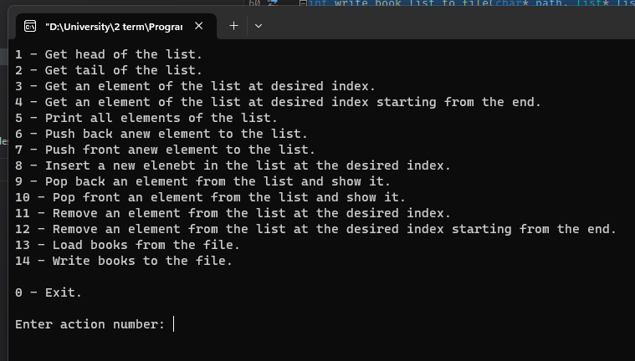

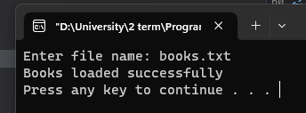

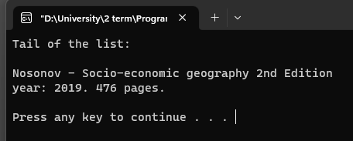
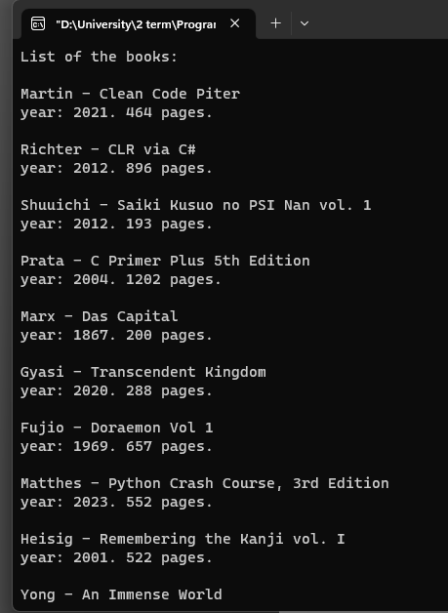
Содержимое файлов
books.txt – исходный файл, из которого считываются книги.
